**Supplementary material**

Trindade DPF, Carmona CP, Reitalu T, Pärtel M. 2022. Observed and dark diversity dynamics over millennial time scales: fast-life history traits linked to expansion lags of plants in Northern Europe (<https://doi.org/10.1098/rspb.2022-1904>)

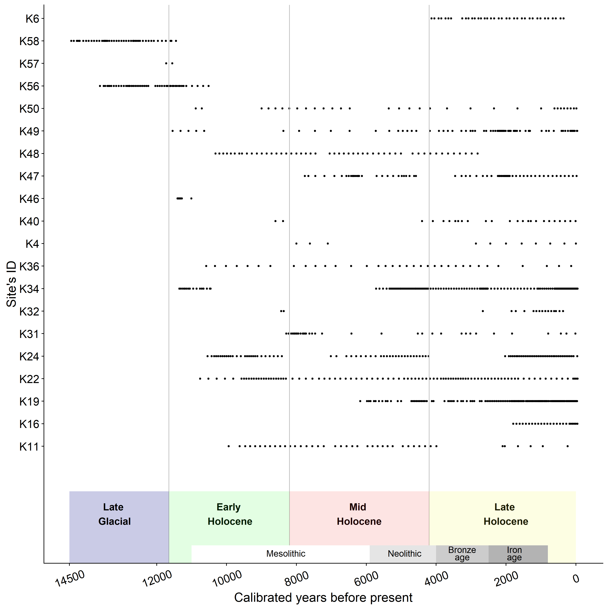

*Figure* S1*.*  Temporal range cover per site, from 14500 years before present (cal. yr BP) until the present in Northern Europe.

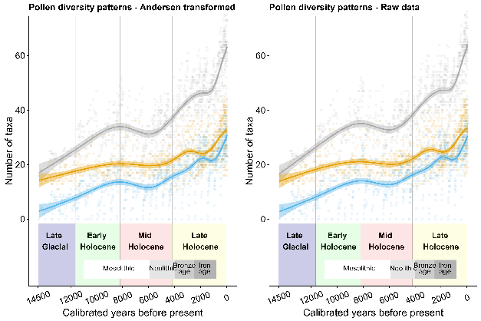

*Figure* *S2.* Comparison between Andersen transformed and raw pollen data, depicting that the diversity patterns in both datasets are similar. Number of taxa in both observed and dark diversity, as well species pool size of sites in NE Europe over the past 14500 years (cal. yr BP). Lines represent the fits of GAM and shaded areas the 95% confidence intervals

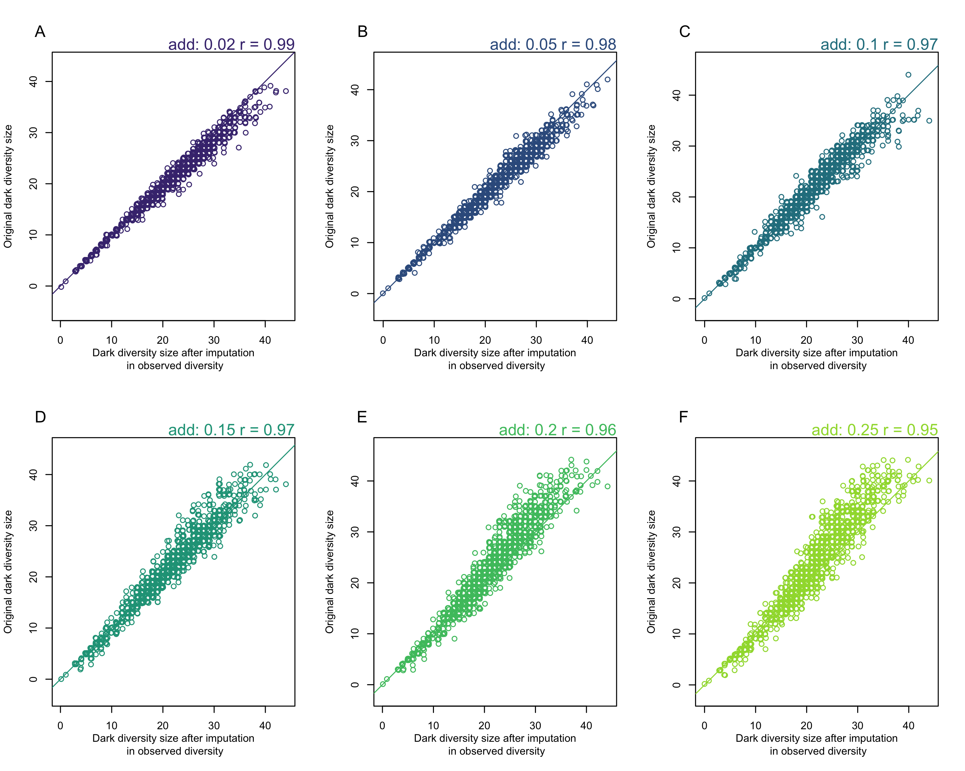

*Figure* S3*.* Correlation between original dark diversity and dark diversity results after randomly adding a percentage of highly suitable taxa to observed diversity (2%,5%,10%,15%,20%,25%). Even after adding 25% of highly suitable taxa to observed diversity, the correlation between the original dark diversity size and the one after imputation is still high (95%), suggesting that sampling bias issue is minimal in our dark diversity results. The identity line is drawn on each graph.

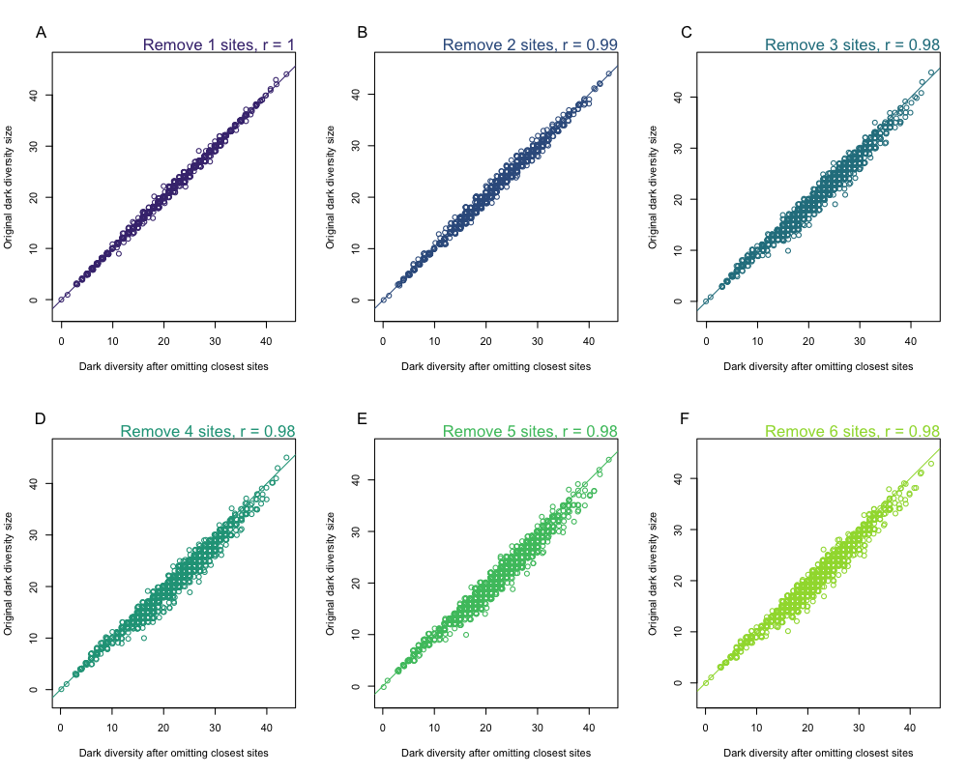

*Figure* S4*.* Correlation between original dark diversity and dark diversity results after removing closest sites (1-6 sites). The correlation between the original dark diversity size and the dark diversity size after removing six closest sites is still high (98%), suggesting that autocorrelation issue is minimal in our dark diversity results. The identity line is drawn on each graph.

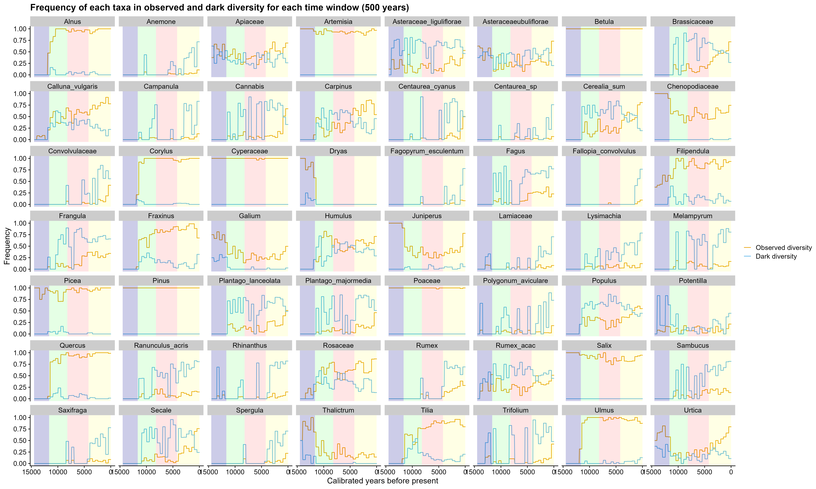

*Figure* S5*.* Relative frequency of taxa in observed and dark diversity from 14500 years before present (cal. yr BP) until the present. The relative frequency of taxa was calculated for each 500-year time window using the number of times taxa occupied a site (observed diversity) or were suitable but absent (dark diversity) divided by the number of sites at each time window. Only taxa with more than 70% of frequency either within observed or dark diversity in any time window are shown.

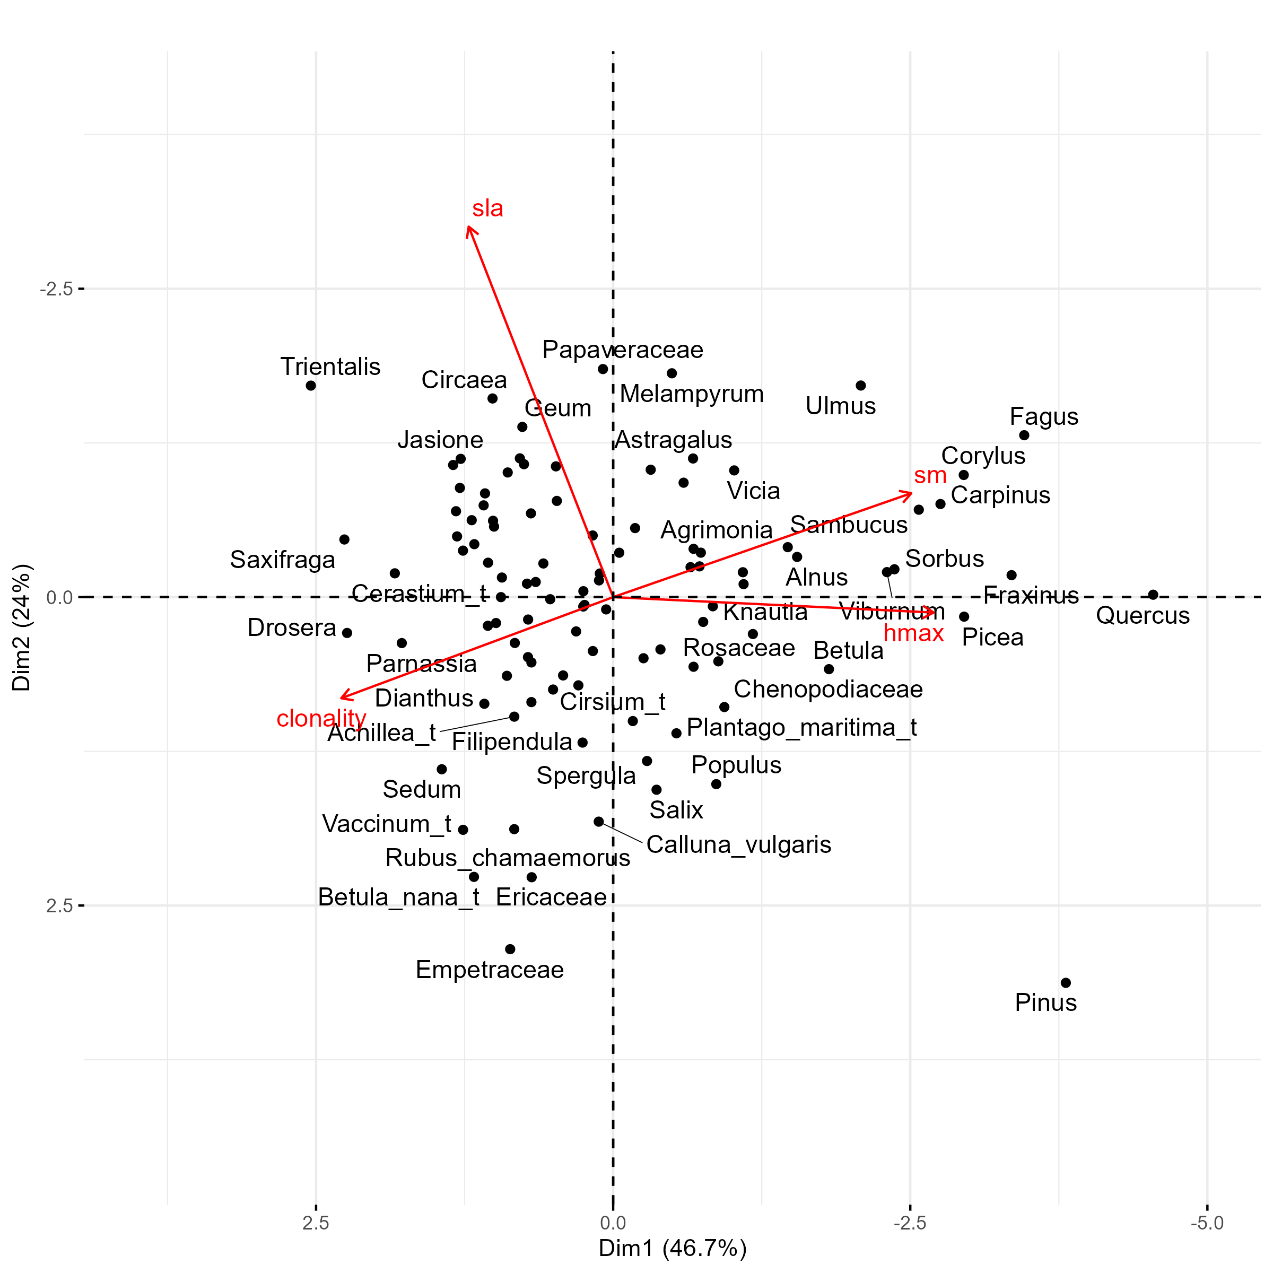

*Figure* S6*.*  Principal component analysis of the functional spectra of plants in Northern Europe, depicting the first axis represented by Height (hmax), seed weight (sm) and clonality and the second axis represented by specific leaf area (sla). The first axis (PC1) explains 46.7% of the total variation and the second axis (PC2) explains 24% of the total variation.

Table S1. Details of pollen datasets used in the study. The number of used samples, study period (in calibrated years before 1950), number of dates, coordinates and the reference are given for each site.

| Site | No. of samples | Period (cal. yr. BP) | No. of dates | Coordinates | Lake/  bog | Reference | Neotoma database link  (neotomadb.org) |
| --- | --- | --- | --- | --- | --- | --- | --- |
| Hino (K_ID: K6) | 36 | 4130 – 351 | 4 | 57.583056 °N  27.238611 °E | bog | Laul, S. & Kihno, K. 1999. Prehistoric land use and settlement history on the Haanja Heights, southeastern Estonia, with special reference to the Siksali-Hino area. *PACT* 57: 239–254. | Neotoma ID: 29180 |
| Kahala (K_ID: K11) | 42 | 9940 – 236 | 13 | 59.486740 °N  25.531503 °E | lake | Poska, A.& Saarse, L. 1999. Holocene vegetation and land-use history in the environs of Lake Kahala, northern Estonia. V*egetation History and Archaeobotany* 8:185–197. | https://doi.org/10.21233/p0mn-7534 |
| Kiilaspere (K_ID: K16) | 24 | 1791 –  (-44) | 3 | 58.796944 °N  24.436111 °E | bog | Veski, S. 1998. Vegetation history, human impact and palaeogeography of West Estonia. Pollen analytical studies of lake and bog sediments. *Striae* 38: 3–119. | Neotoma ID: 29193 |
| Kunda Arusoo (K_ID: K4) | 11 | 7999 – 0 | 9 | 59.466667 °N  26.521944 °E | bog | Poska, A. & Königsson, L.-K. 1996. Traces of Mesolithic land-use in a pollen diagram from the Arusoo Mire at Kunda. *PACT* 51: 299–309. | Neotoma ID: 29106 |
| Lasva (K_ID: K19) | 152 | 6172 –  (-36) | 5 | 57.859444 °N  27.175000 °E | lake | Niinemets, E. & Saarse, L. 2007. Fine-resolution pollen-based evidences of farming and forest development, south-eastern Estonia. *Polish Journal of Ecology* 55: 283–296. | Neotoma ID: 29176 |
| Lielais Svētiņu (K_ID: K58) | 48 | 14443 – 11448 | 12 | 56.759081 °N  27.149122 °E | lake | Veski, S., Amon, L., Heinsalu, A., Reitalu, T., Saarse, L., Stivrins, N. & Vassiljev, J. 2012. Lateglacial vegetation dynamics in the eastern Baltic region between 14,500 and 11,400 cal yr BP: A complete record since the Bølling (GI-1e) to the Holocene. *Quaternary Science Reviews* 40: 39–53. | https://doi.org/10.21233/ZNR8-K992 |
| Maardu (K_ID: K22) | 94 | 10755 –  (-50) | 8 | 59.441667 °N  25.000000 °E | lake | Veski, S. 1998. Vegetation history, human impact and palaeogeography of West Estonia. Pollen analytical studies of lake and bog sediments. *Striae* 38: 3–119. | https://doi.org/10.21233/45g4-ry85 |
| Mustjärve (K_ID: K24) | 91 | 10544 –  (-40) | 7 | 59.076944 °N  24.099722 °E | bog | Veski, S. 1998. Vegetation history, human impact and palaeogeography of West Estonia. Pollen analytical studies of lake and bog sediments. *Striae* 38: 3–119. | https://doi.org/10.21233/3pzj-0y37 |
| Nakri (K_ID: K56) | 49 | 13621 – 10512 | 9 | 57.895119 °N  26.273144 °E | lake | Amon, L., Veski, S., Heinsalu, A. & Saarse, L. 2012. Timing of Lateglacial vegetation dynamics and respective palaeoenvironmental conditions in southern Estonia: evidence from the sediment record of Lake Nakri. *Journal of Quaternary Science* 27: 169–180. | https://doi.org/10.21233/p0mn-7534 |
| Pitkasoo (K_ID: K31) | 34 | 8288 – 12 | 7 | 58.273611 °N  22.217222 °E | bog | Königsson, L.-K. & Poska, A., 1998. Pitkasoo – a West Estonian Holocene reference site. *Proceedings of the Estonian Academy of Sciences. Geology* 47: 242–261. | https://doi.org/10.21233/0J6Y-2769 |
| Plaani (K_ID: K32) | 17 | 8437 – 367 | 8 | 57.676944 °N  27.077222 °E | lake | Niinemets, E. & Saarse, L. 2007. Mid- and late-Holocene land-use changes inferred from pollen records, in a south-eastern Estonian upland area. *Review of Palaeobotany and Palynology* 146: 51–73. | https://doi.org/10.21233/zdqt-kr34 |
| Rõuge (K_ID: K34) | 158 | 11350 –  (-49) | Varves | 57.738889 °N  26.905000 °E | lake | Veski, S., Koppel, K. & Poska, A. 2005. Integrated palaeoecological and historical data in the service of fine-resolution land use and ecological change assessment during the last 1000 years in Rõuge, southern Estonia. *Journal of Biogeography* 32: 1473–1488. | The data has been submitted to Neotoma. Meanwhile it can be obtained from the authors or from Siim Veski (siim.veski@taltech.ee) |
| Ruila (K_ID: K36) | 35 | 10582 – 134 | 14 | 59.175833 °N  24.429722 °E | lake | Poska, A. & Saarse, L. 2002. Biostratigraphy and 14C dating of a lake sediment sequence on the north-west Estonian carbonaceous plateau, interpreted in terms of human impact in the surroundings. *Vegetation History and Archaeobotany* 11: 191–200. | https://doi.org/10.21233/8c8d-g988 |
| Surusoo (K_ID: K40) | 25 | 8600 – 6 | 15 | 58.529722 °N  22.423056 °E | bog | Veski, S. 1998. Vegetation history, human impact and palaeogeography of West Estonia. Pollen analytical studies of lake and bog sediments. *Striae* 38: 3–119. | https://doi.org/10.21233/47K2-XV64 |
| Udriku (K_ID: K57) | 2 | 11727 – 11551 | 4 | 59.371861 °N  25.931536 °E | lake | Amon, L. & Saarse, L. 2010. Postglacial palaeoenvironmental changes in the area surrounding Lake Udriku in North Estonia. *Geological Quaterly* 54: 85–94.  Veski, S., Seppä, H., Stančikaitė, M., Zernitskaya, V., Reitalu, T., Gryguc, G., Heinsalu, A., Stivrins, N., Amon, L., Vassiljev, J., & Heiri, O. (2015). Quantitative summer and winter temperature reconstructions from pollen and chironomid data between 15 and 8 ka BP in the Baltic–Belarus area. *Quaternary International*, *388*, 4–11. | Neotoma ID: 29167 |
| Vaskna (K_ID: K46) | 7 | 11404 – 11009 | 16 | 57.711667 °N  27.078333 °E | lake | Ilves, E. & Mäemets, H. 1987. Results of radiocarbon and palynological analyses of coastal deposits of lakes Tuuljarv and Vaskna. *Palaeohydrology of the Temperate Zone III. Mires and Lakes*. (ed. by A. Raukas and L. Saarse), pp. 108–130. Valgus, Tallinn. | Neotoma ID: 29161 |
| Vedruka (K_ID: K47) | 70 | 7756 –  (-19) | 12 | 58.330278 °N  22.060556 °E | bog | Poska, A. & Saarse, L. 2002. Vegetation development and introduction of agriculture to Saaremaa Island, Estonia: the human response to shore displacement. *The Holocene* 12: 555–568. | https://doi.org/10.21233/93QR-E085 |
| Velise (K_ID: K48) | 50 | 10316 – 2814 | 8 | 58.756667 °N  24.460278 °E | bog | Veski, S. 1998. Vegetation history, human impact and palaeogeography of West Estonia. Pollen analytical studies of lake and bog sediments. *Striae* 38: 3–119. | Neotoma ID: 29165 |
| Verijärv (K_ID: K49) | 85 | 11544 –  (-38) | 7 | 57.808333 °N  27.058333 °E | lake | Niinemets, E. & Saarse, L. 2006. Holocene forest dynamics and human impact in southeastern Estonia. *Vegetation History and Archaeobotany* 16: 1–13. | https://doi.org/10.21233/ap4h-y067 |
| Viitna Pikkjärv (K_ID: K50) | 32 | 10881 –  (-17) | 9 | 59.446389 °N  26.010556 °E | lake | Saarse, L., Poska, A., Kaup, E. & Heinsalu, A. 1998. Holocene environmental events in the Viitna area, North Estonia. *Proceedings of the Estonian Academy of Sciences. Geology* 47: 31–44. | https://doi.org/10.21233/2tkh-z079 |

Table S2. Generalized additive model (GAM) results for the taxonomic observed and dark diversity and species pool size over the last 14500 years in Northern Europe.

|  |  |  |  |  |  |
| --- | --- | --- | --- | --- | --- |
| **Component** | **Term** | **Estimate** | **Std Error** | **t-value** | **p-value** |
| A. parametric coefficients | (Intercept) | 42.04 | 0.19 | 219.86 | <0.01 |
| divobs | -17.95 | 0.27 | -66.37 | <0.01 |
| divdark | -24.09 | 0.27 | -89.10 | <0.01 |
| **Component** | **Term** | **edf** | **Ref. df** | **F-value** | **p-value** |
| B. smooth terms | s(ybp):divpool | 8.88 | 8.99 | 386.88 | <0.01 |
| s(ybp):divobs | 8.80 | 8.98 | 72.35 | <0.01 |
| s(ybp):divdark | 8.35 | 8.78 | 133.67 | <0.01 |
| Adjusted R-squared: 0.81, Deviance explained 0.81 | | | | | |
| GCV: 39.19, Scale est.: 38.83, N: 3186 | | | | | |

Table S3. Generalized additive model (GAM) results for the taxonomic community completeness over the last 14500 years in Northern Europe.

|  |  |  |  |  |  |
| --- | --- | --- | --- | --- | --- |
| **Component** | **Term** | **Estimate** | **Std Error** | **t-value** | **p-value** |
| A. parametric coefficients | (Intercept) | 0.37 | 0.02 | 22.26 | <0.01 |
| **Component** | **Term** | **edf** | **Ref. df** | **F-value** | **p-value** |
| B. smooth terms | s(ybp) | 8.06 | 8.59 | 29.51 | <0.01 |
| Adjusted R-squared: 0.19, Deviance explained 0.20 | | | | | |
| GCV: 0.28, Scale est.: 0.28, N: 1028 | | | | | |

Table S4. Generalized additive model (GAM) results for the functional observed and dark diversity and species pool size over the last 14500 years in Northern Europe.

|  |  |  |  |  |  |
| --- | --- | --- | --- | --- | --- |
| **Component** | **Term** | **Estimate** | **Std Error** | **t-value** | **p-value** |
| A. parametric coefficients | (Intercept) | 31.62 | 0.07 | 471.21 | <0.01 |
| variableObserved | -3.60 | 0.09 | -37.90 | <0.01 |
| variableDark | -28.02 | 0.09 | -295.29 | <0.01 |
| **Component** | **Term** | **edf** | **Ref. df** | **F-value** | **p-value** |
| B. smooth terms | s(ybp):variablePool | 6.14 | 6.99 | 297.93 | <0.01 |
| s(ybp):variableObserved | 7.76 | 8.36 | 159.60 | <0.01 |
| s(ybp):variableDark | 8.19 | 8.68 | 13.69 | <0.01 |
| Adjusted R-squared: 0.97, Deviance explained 0.97 | | | | | |
| GCV: 4.82, Scale est.: 4.78, N: 3186 | | | | | |

Table S5. Generalized additive model (GAM) results for the functional community completeness over the last 14500 years in Northern Europe.

|  |  |  |  |  |  |
| --- | --- | --- | --- | --- | --- |
| **Component** | **Term** | **Estimate** | **Std Error** | **t-value** | **p-value** |
| A. parametric coefficients | (Intercept) | 2.28 | 0.03 | 74.62 | <0.01 |
| **Component** | **Term** | **edf** | **Ref. df** | **F-value** | **p-value** |
| B. smooth terms | s(ybp) | 7.44 | 8.11 | 7.37 | <0.01 |
| Adjusted R-squared: 0.05, Deviance explained 0.06 | | | | | |
| GCV: 0.95, Scale est.: 0.94, N: 1011 | | | | | |

Table S6. Generalized additive model (GAM) results for mean trait values (first axis of the PCA - Height, seed weight and clonality) in observed and dark diversity over the last 14500 years in Northern Europe.

|  |  |  |  |  |  |
| --- | --- | --- | --- | --- | --- |
| **Component** | **Term** | **Estimate** | **Std Error** | **t-value** | **p-value** |
| A. parametric coefficients | (Intercept) | -1.12 | 0.01 | -115.05 | <0.01 |
| divDark | 0.82 | 0.01 | 59.30 | <0.01 |
| **Component** | **Term** | **edf** | **Ref. df** | **F-value** | **p-value** |
| B. smooth terms | s(ybp):divObserved | 8.65 | 8.96 | 51.98 | <0.01 |
| s(ybp):divDark | 8.89 | 9.00 | 108.43 | <0.01 |
| Adjusted R-squared: 0.70, Deviance explained 0.70 | | | | | |
| GCV: 0.1, Scale est.: 0.1, N: 2083 | | | | | |

Table S7. Generalized additive model (GAM) results for mean trait values (second axis of the PCA - SLA) in observed and dark diversity over the last 14500 years in Northern Europe.

|  |  |  |  |  |  |
| --- | --- | --- | --- | --- | --- |
| **Component** | **Term** | **Estimate** | **Std Error** | **t-value** | **p-value** |
| A. parametric coefficients | (Intercept) | 0.30 | 0.01 | 40.95 | <0.01 |
| divDark | -0.39 | 0.01 | -37.38 | <0.01 |
| **Component** | **Term** | **edf** | **Ref. df** | **F-value** | **p-value** |
| B. smooth terms | s(ybp):divObserved | 7.92 | 8.69 | 40.24 | <0.01 |
| s(ybp):divDark | 7.57 | 8.49 | 32.33 | <0.01 |
| Adjusted R-squared: 0.50, Deviance explained 0.50 | | | | | |
| GCV: 0.06, Scale est.: 0.06, N: 2083 | | | | | |